Uploading Fort Macarena Chronicles...
Loading....
Extracting readable data....
First Transmission Starts:

-Extract from the Diary of Thaler, Mute Lesbian and Colonist.

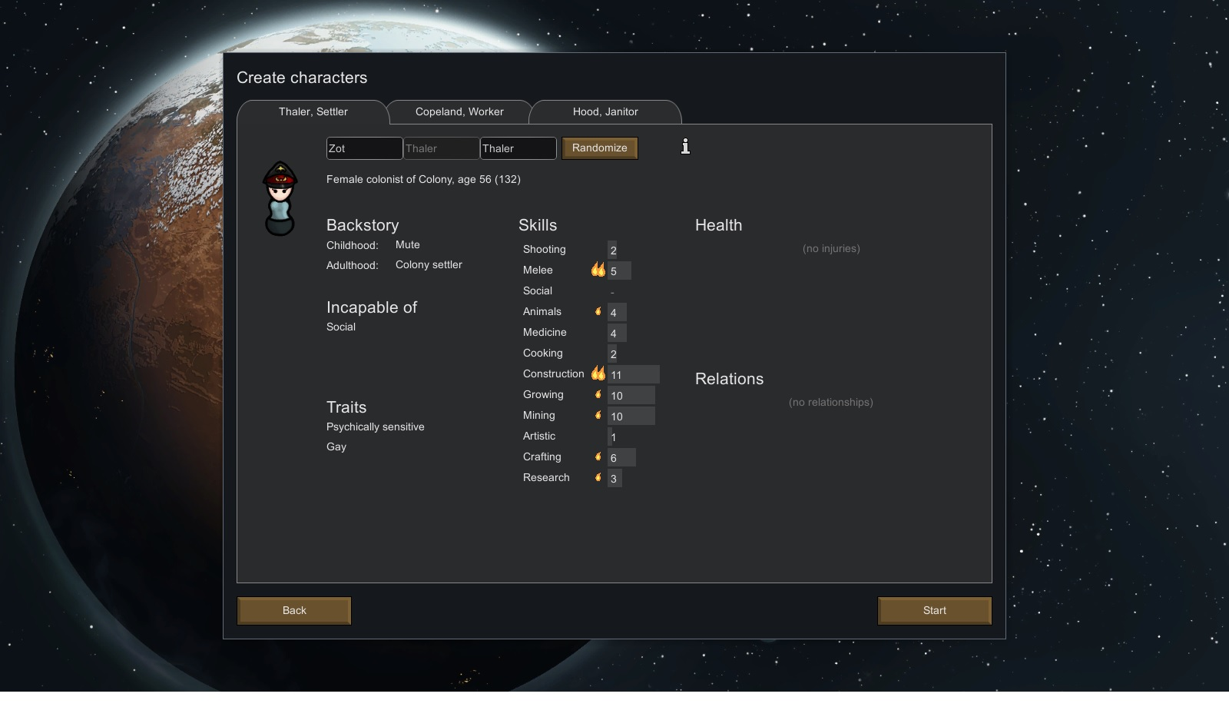
''I should have know this was a bad idea. They needed women on the outer Rimworlds for ''stuff'' (...) Even if I tried to explain to them (good luck as a mute) that a lesbian would not make the best candidate to ''increase'' the population of new colonies; they would'nt listen. So I gave in. Money was good. One Standard Galactic year in and out they said. Shit even the name of the ship sounded crappy. Persecution. Great f-ing way to entice people to join.''

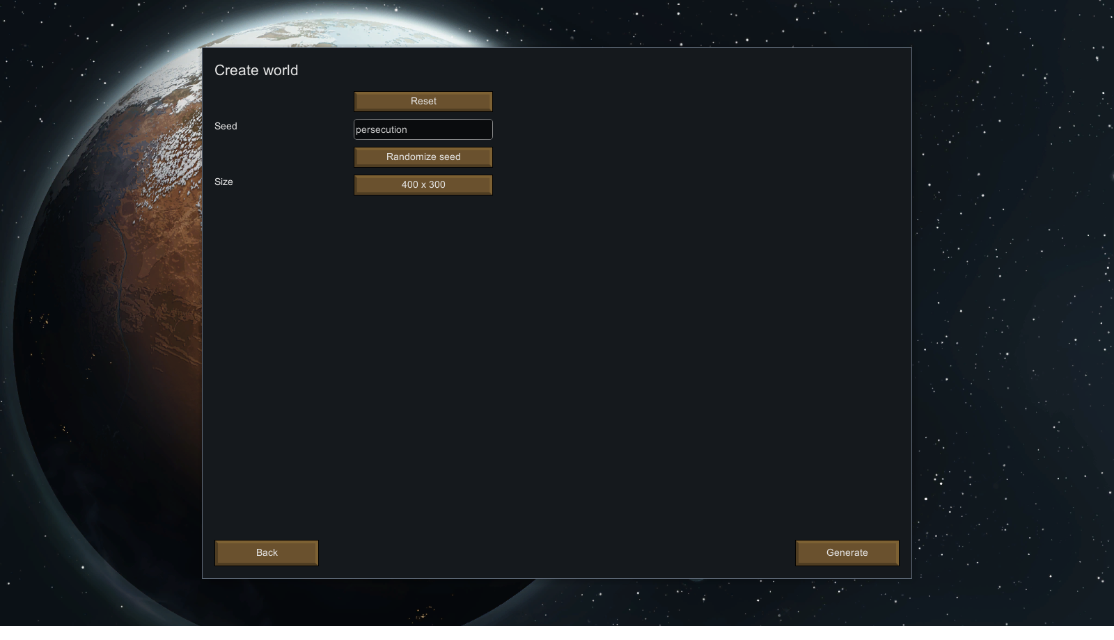
-Extract from the Diary of Saburo Hood. Ship Janitor of the Persecution

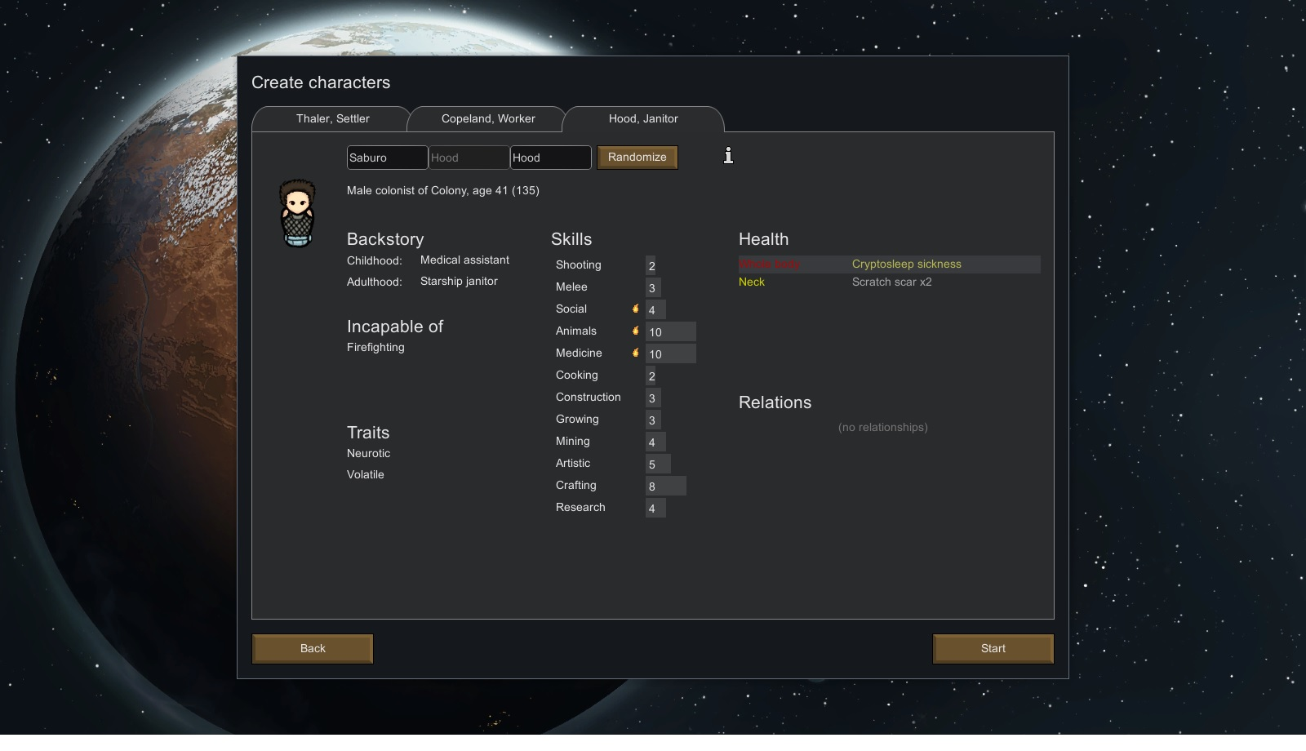
''Mop the corners, first diagonally yes, then horizontally yes, so they cannot see the pattern. See the pattern. Sabuto knows what is good to stay low, yes. They must not find the pattern. The pattern is the code, the code is life. Yes. They must not see the pattern.” * Mops floors frantically* Scratches his Neck aggressively.

-Extract from the Gibberish that is the Diary of Howard Copeland, Factory Worker.

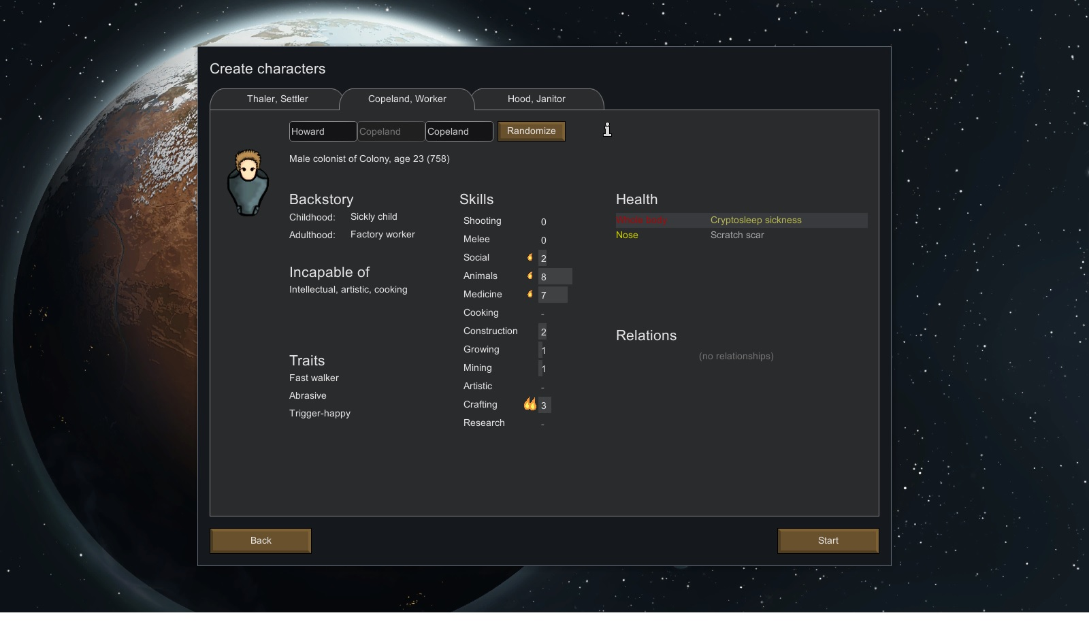
'' Howard. Howard ? Howard Howard! Howard(...) Howard.''

-Extract from the diary of Hardship. The Dog. Why dogs have journals if they can't talk? Because fuck you. Thats why.

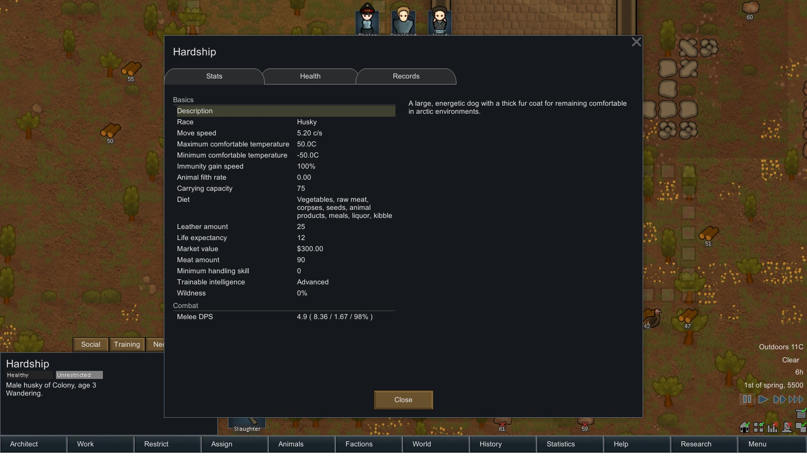
''Lights, loud noise ? What happening ? What is it ? Where is master ? Why hooman running ? Quick quick here ! Says Mop Human. Quick ! Follow Hooman. New Master. We go in Big Egg. Pshhhh light. Big Hooman here too with silent female hooman. Pshhh light. Crash!

End of First Transmission.

DAY 1: It begins !
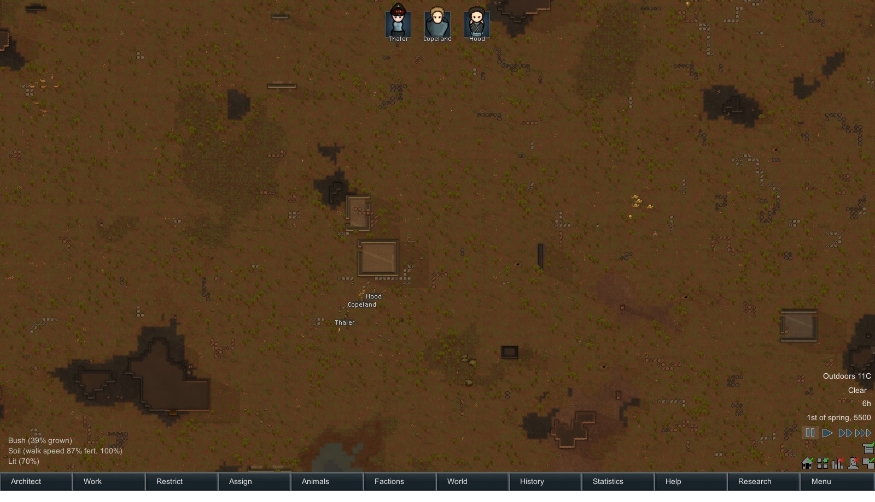
So it begins ! We have a mute lesbian, a crazy neurotic janitor and a big dumb dumb. Looks like bad Hollywood sitcom. Looks like we landed in a small hills area. There is a few ores around here but not much. Not much cover either. Good thing is we landed next to a fertile area and some buildings. Beter Get started.

Who's around ?
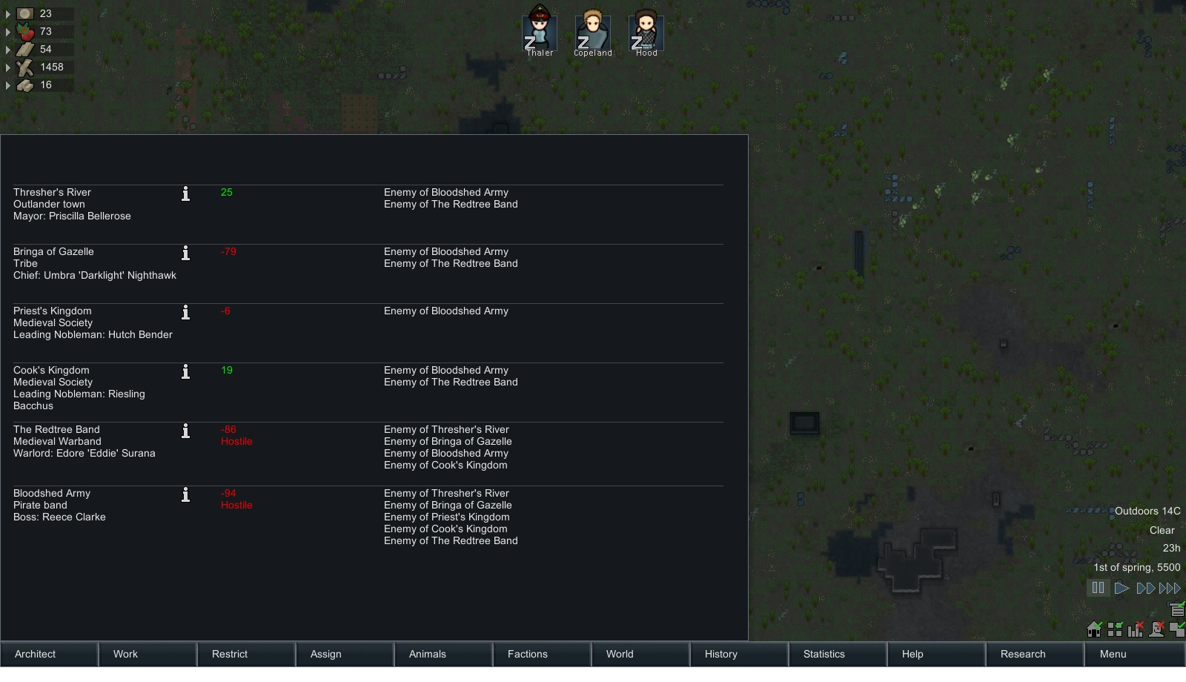
OHHHHH ! We have sooooo many friends. So much FUN lies up ahead !

Day 2: Lets get set-up!

Loading....
Extracting readable data....
Second Transmission Starts:

Extract from the Diary of Thaler, Colonist and leader that didn't want to become one.
'' Well I am fucked. I knew it. The ''Persecution'' went kapput and I barely escaped with a few other passengers. So now its me, a guy that wont stop talking to himself that will probably try to murder me in my sleep and this big dumb dumb, who thanks to which ever f-ing deity you want to pray to is not aggressive. And that dog that won't stop humping trees after trees. Anyhow. At least the planet has a breathable atmosphere. If I am able to set-up a radio, maybe I can teach dumb dumb enough words or coach Mr Crazy to hail our ship and get us out of there. So now we managed to get cozy in a few abandoned ruins got some seeds planted so we can grow food for a few days. I am on a break updating my diary but today I have been working the past hours on setting up a wind turbine that should... FUCK Crazy DUDE ! Don't touch it ! ... The wiring is ....

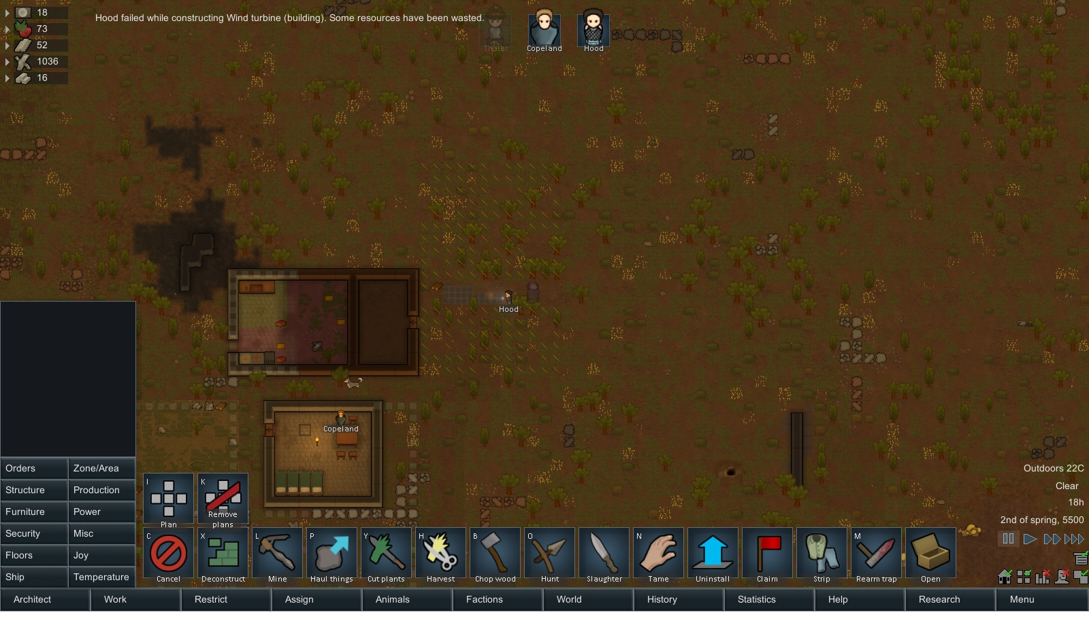
Hood sucks.

Extact from Thaler's diary: FML.

End of Second Transmission.

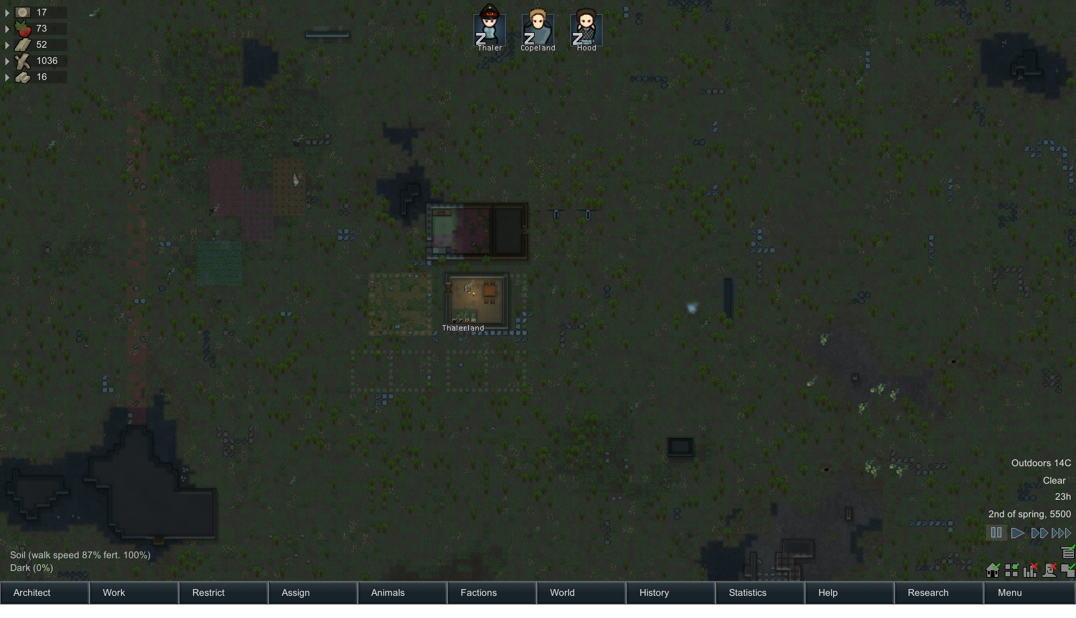
So at the end of Second day we got the fields set-up, the main hall, a few wind turbines are up, the food storage area is good as well.

Day 3: We've got visitors !
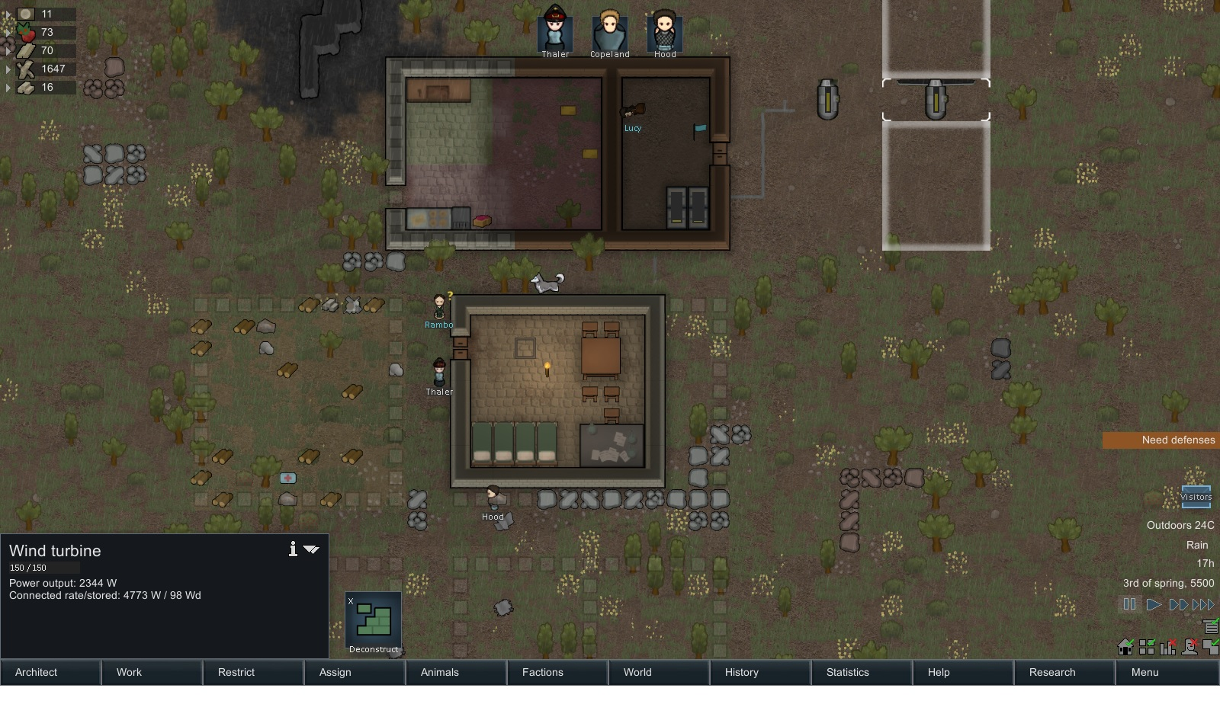
Yeah ! Visitors. Lets hope they like sleeping on the floor.

Loading....
Extracting readable data....
Third Transmission Starts:

Extract from the diary of Howard Copeland, Dumb Dumb.
*Points at Rambo, visitor * ''Howard ? Howard !. Howard''. *Rambo Points at Howard* ''Rambo-Rambo ! Rambo !''. * They shake hands * *Rambo drops medical herbs* *Howard gives him 4 silver*

*Hood and Thaler look at each other puzzled by what just occurred*

End Third Transmission

Day 4: Bye bye Visitors and local fauna violence
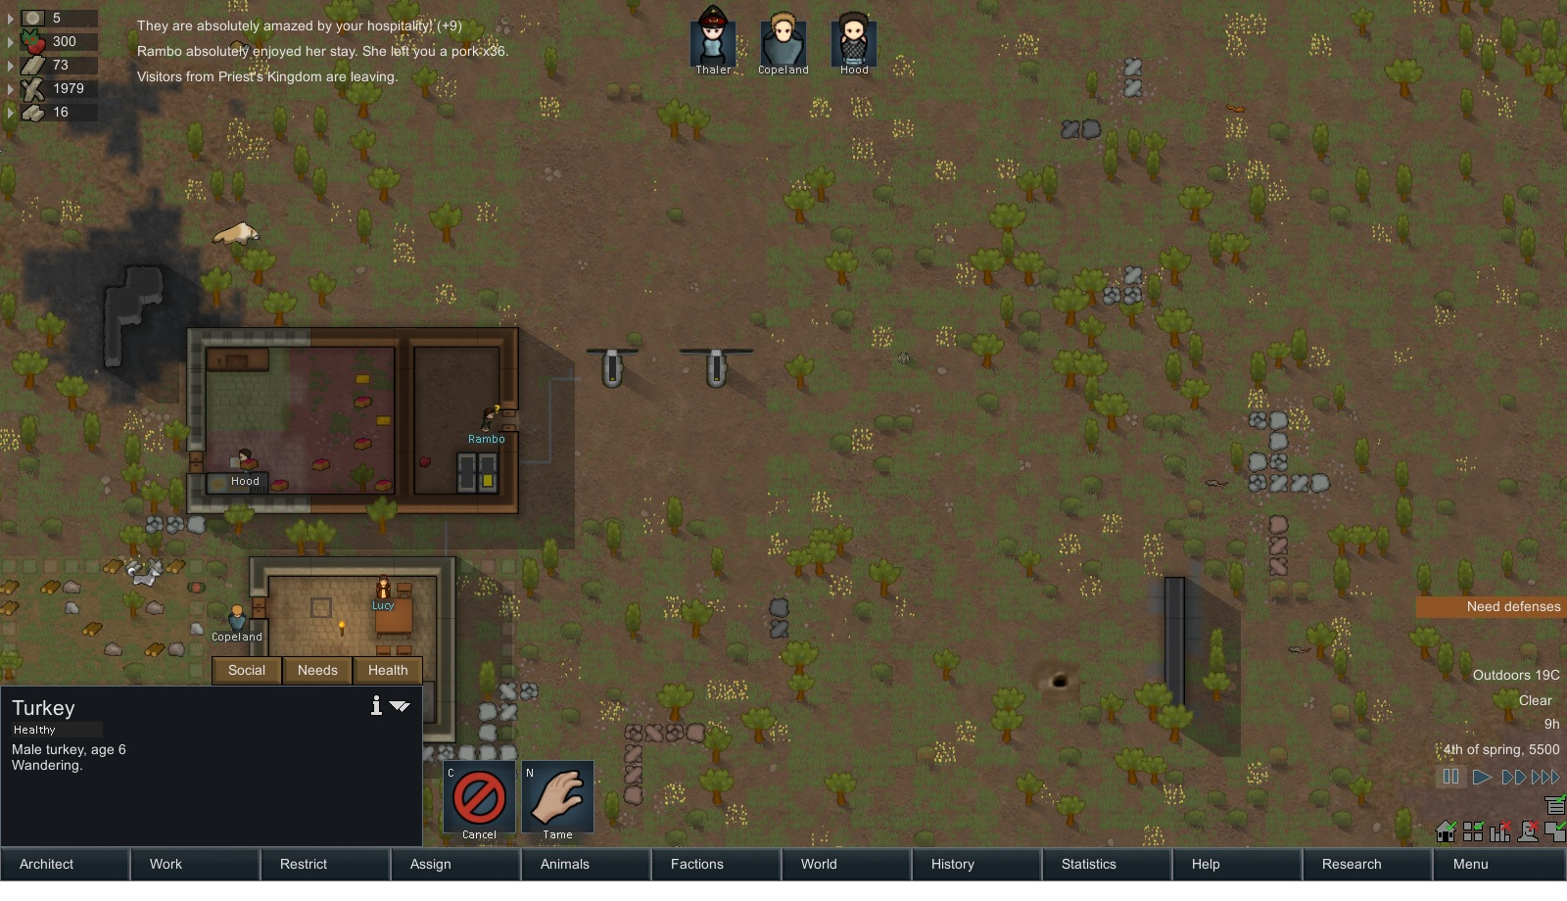
After sleeping on the dirt floor next to humming batteries, visitors are Amazed by our Hospitality. Go figure. Maybe I should open an hotel for tribals under my front porch.

Loading....
Extracting readable data....
Fourth Transmission Starts:

Extract from Hood Diary:

'' This place, has secret, yes. The secret of this place are secret. Yes. They shall be mine yes. But the others, the mute one and Dumb Dumb. They want them too. I must guard my secret yes. Hardship is a good dog but he will never hurt them yes. I need a new ferocious animal. A new beast to train as a warrior yes. '' *Hood disappears into the bush. *

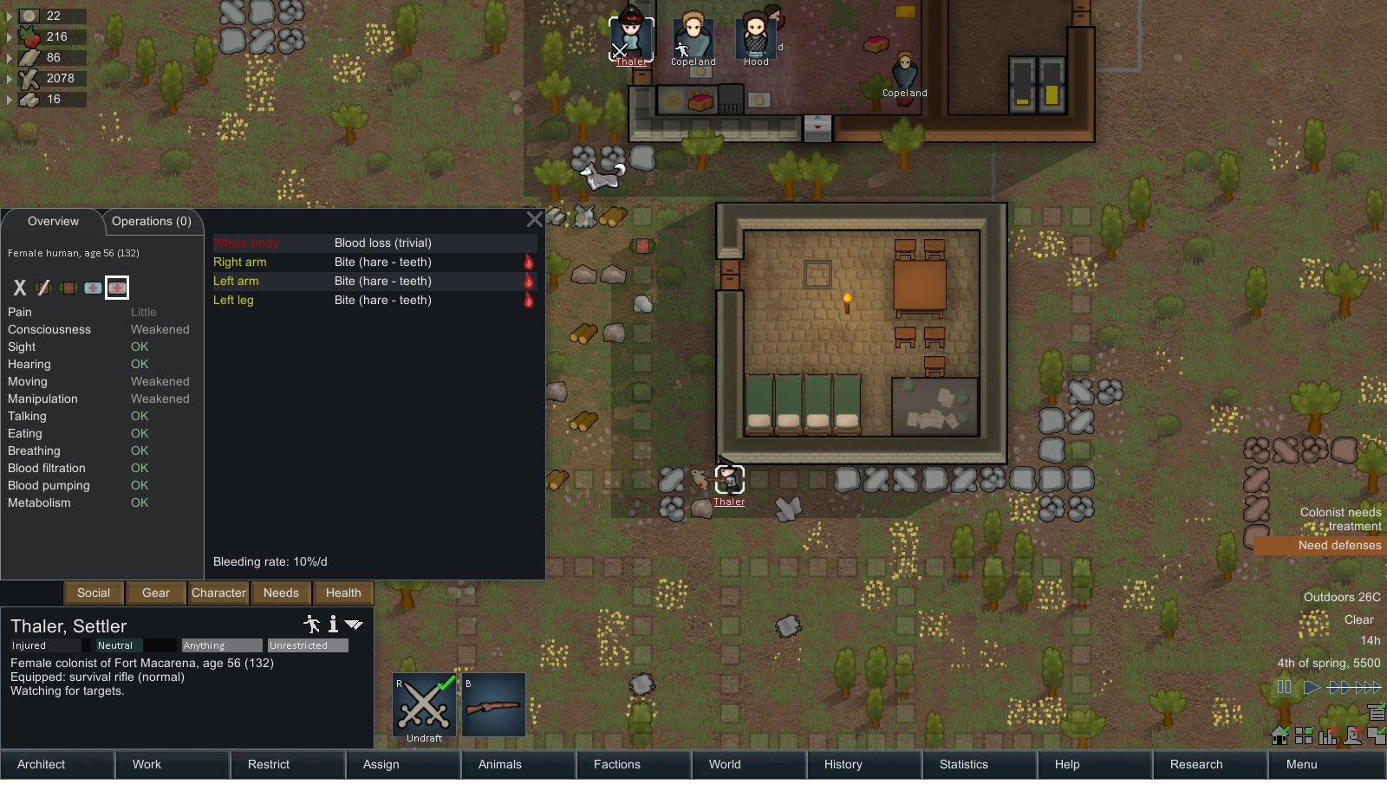
Rabid Hare Attack.

Extract from the diary of Thaler:
'' WTF ! A Fucken Hare? Really ? WTF is wrong with this place ''

Fourth Transmission ends.

Day 5: Wanderer Join and the Macarena
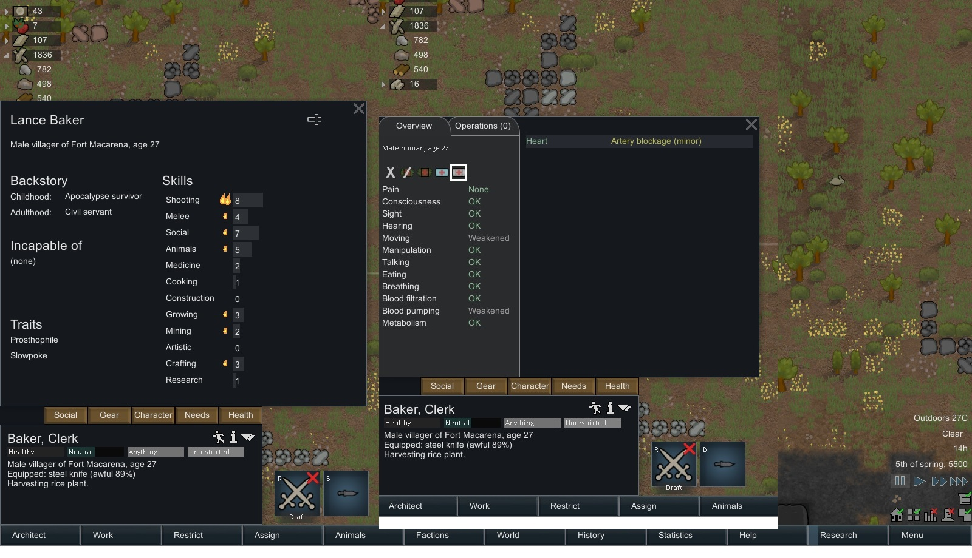
A wanderer join. He seems not too bad, but he is slow and cardiac and hate prosthetics... My gamer senses tells me he will end up with a surrogate heart !

Loading....
Extracting readable data...
Fifth Transmission Starts:

Extract from the Diary of Baker:
''Now you must take it easy Baker. Don't push it too far Baker. That's what they all said when I got my diagnosis on my heart. Shit, I spend my life staying out of trouble, took a nice office job to live a long and happy life and now look where it got me ! Fuck them I said. I quit I said. Off to the wild I went. Bought a ticket to the Rimworlds and ended up here after a few odd and sod jobs. Last mother fucker I worked for let me stranded here but, still at least I am free. Free to Join who I want and where I want.

Extract from the Diary of Hardship, dog. Yes the dog still has a diary. Fuck you.
''Stranger Approaches ! Stranger approaches! Must not like stranger ! *Stranger rubs Hardship's belly* ''Stranger is friend NOW !'

Extract from the Diary of Thaler, Mute lesbian leader.
''So this dude showed up out of nowhere. Asked for food and place to stay for the night. Wasn't sure at first but then Hardship's was all over him, so why not ? It has been awhile anyway I haven't see a person that can talk with more than one word in a cohesive non-neurotic way. So fuck it. Hardship and Dumb dumb were sooo happy we got a new dude that they started dancing around. Baker (the dude's name) then started dancing too around as well. But he started doing that silly dance people used to do eons ago called ''Macarena''. Dumb Dumb got so excited when he saw that he keep pointing at it. I think he never saw it done before. Baker told Him its Called Macarena.

Extract from Howard Diary:
''Howard ! Howard ! Howard ? Ho-mac. Homaca. Ho-Macarena. MACARENA ! MACARENA !

Extract from Hood Diary:
''Yes Macarena ! Its a code !Yes the Stranger knows the code yes ! *Scratches neck frantically

Extract from Baker Diary:
''These guys gave me quite welcome reception. Even if she is quite tough on the outside that girl is not too bad looking either. ''Say, what do you guys call this place ?''

Extract from Thaler Diary:
''Before I can answer, Howard starts chanting MACARENA! MACARENA ! MACARENA. FML. Welcome to Fort Macarena, Mr Baker.
Fifth Transmission ends
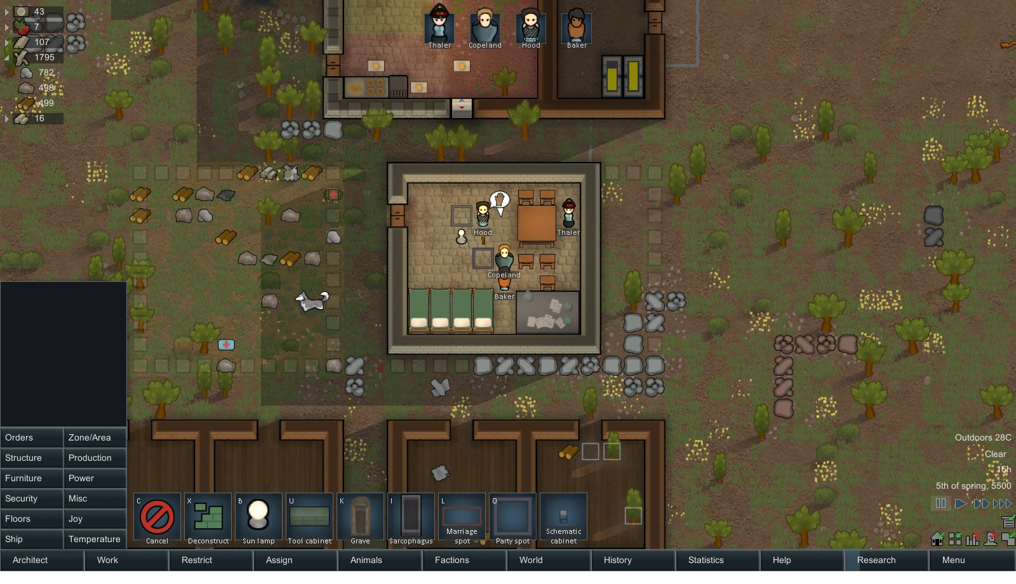
.The Macarena Party.

.

Day 6: We got housing and a RAIDING PARTY !
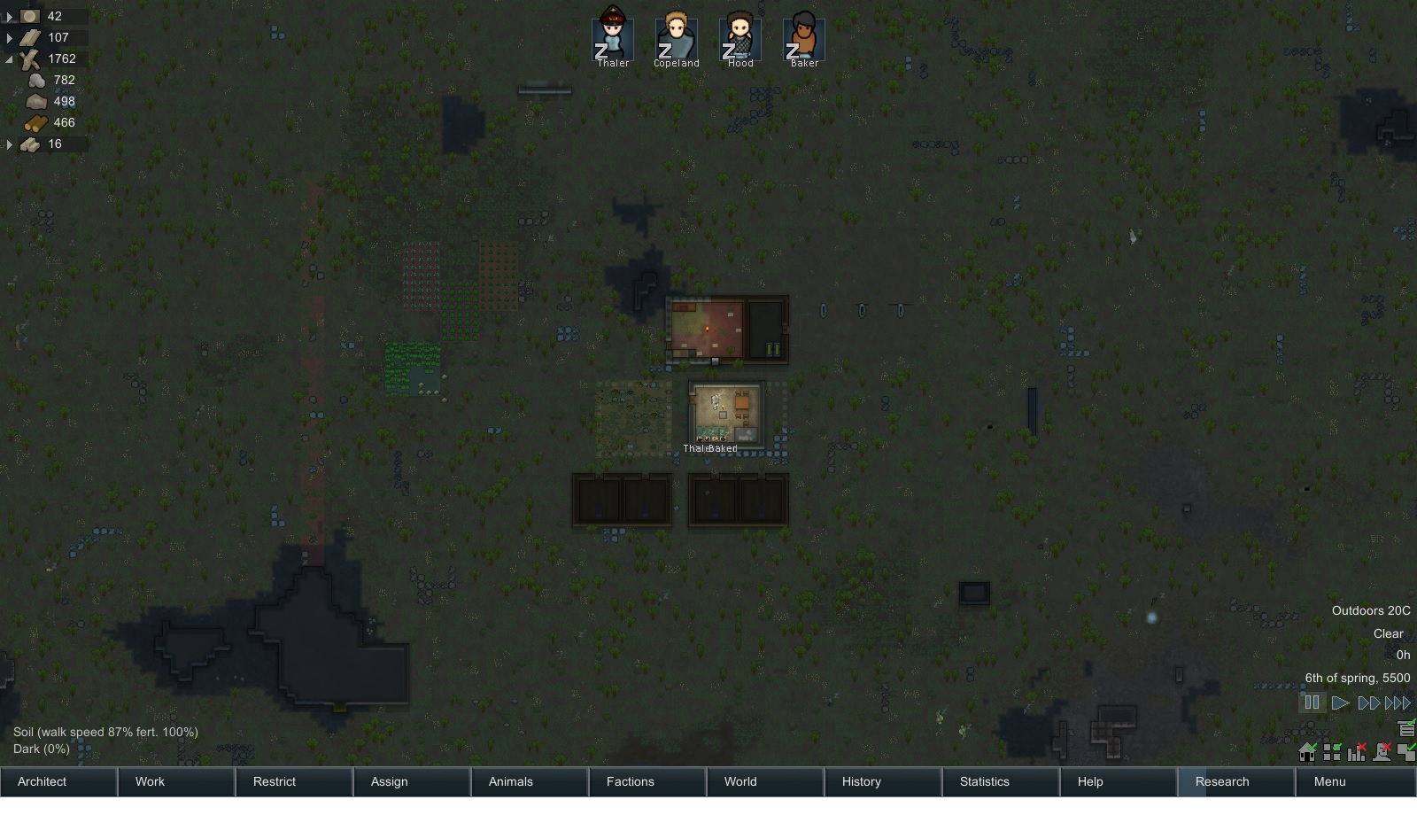
Early morning of the 6th day. We now have accommodations ready for all. We just need to move the furniture in.

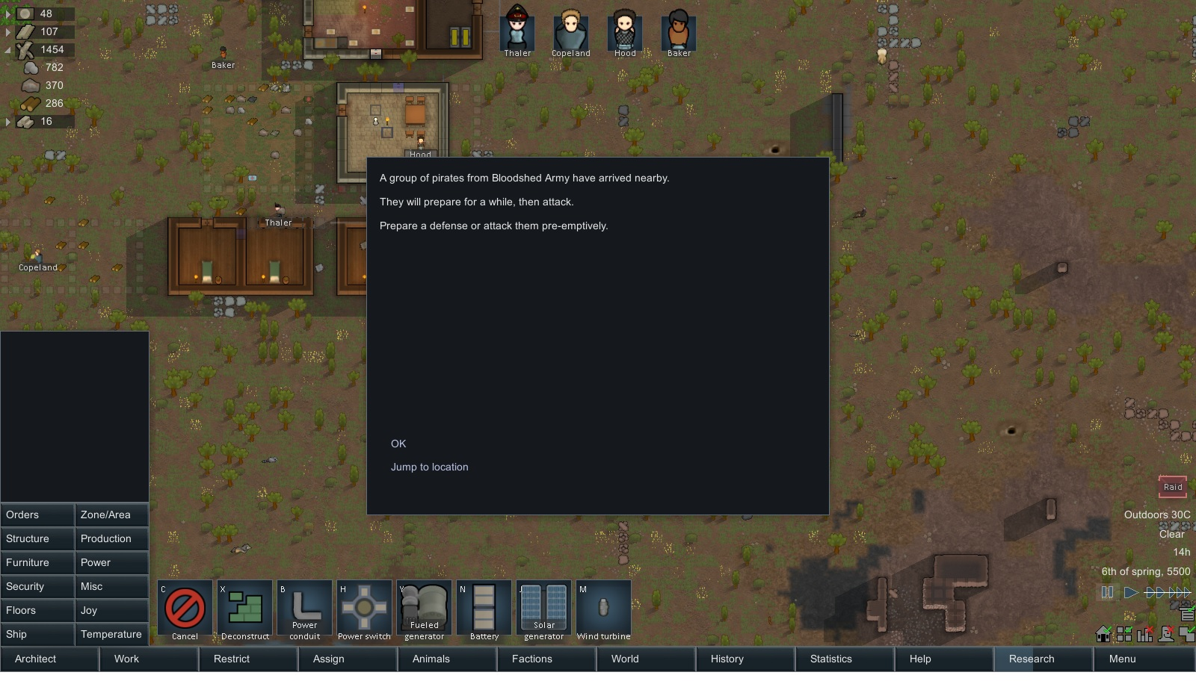
We got company
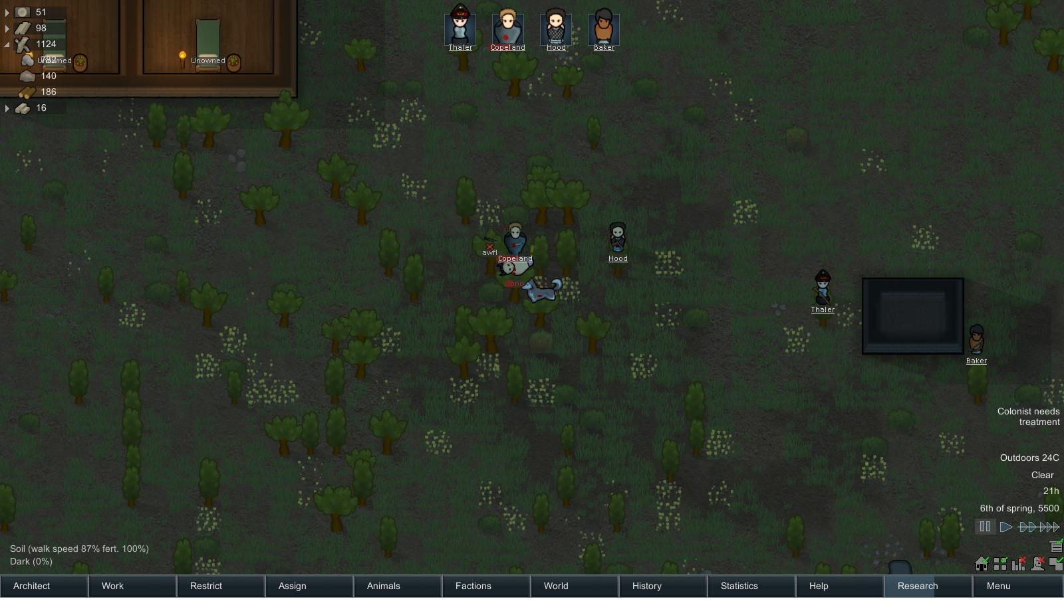
Which we dispose of quickly.We lock him up and we'll figure out what to do with him afterwards.

Day 8: We discovered Stone Cutting!
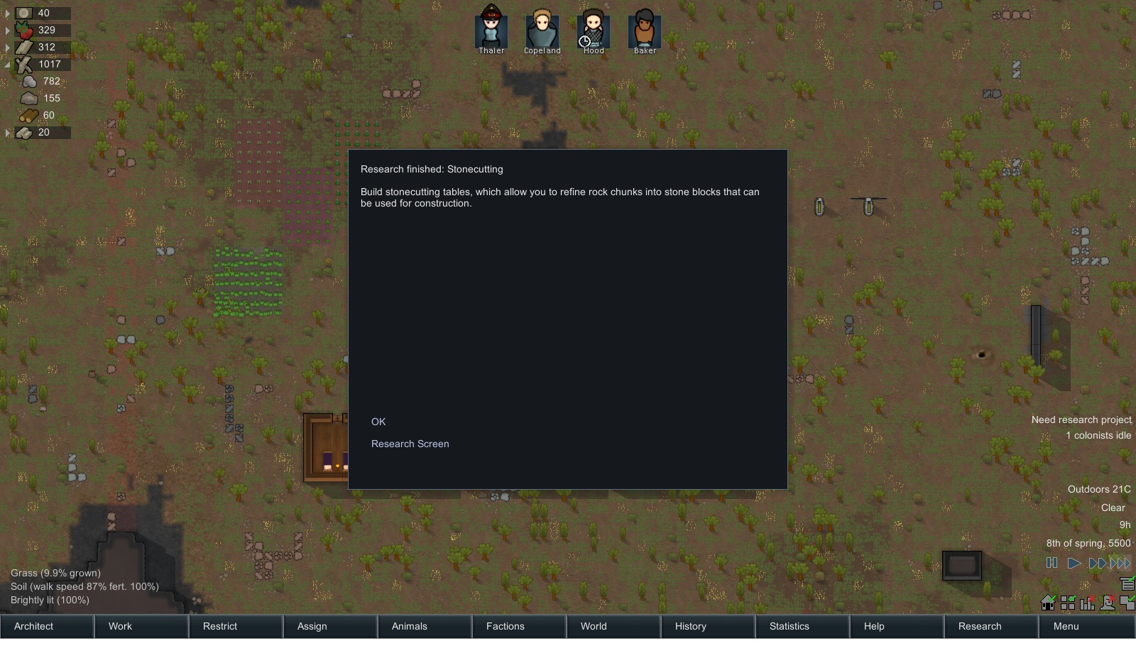
Weeee ! Stonecutting. Next Step: Microelectronics.

Loading....
Extracting readable data....
Sixth Transmission Starts:

Extract from Thaler Diary:
''I cannot believe it. That little twitchy Hood guy was up to something after all. For days now he was sitting on the bench he set up in the corner of the room and keep doing all these drawings and calculation. For awhile, I thought he lost his shit but now today he came out with some basic homemade tools, gave them to Dumb Dumb, gave him a few directions and then Dumb Dumb started mass producing bricks, corners, doors out of stone. These will come handy. Because Jono, our prisoner, started talking. Apparently this planet is not that deserted. We thought he was just a lunatic passing by. But he was here for a reconnaissance patrol. More will be coming soon. We will need defenses soon.

Sixth Transmission ends.

Day 9: Eclipse and Feel the heat baby!
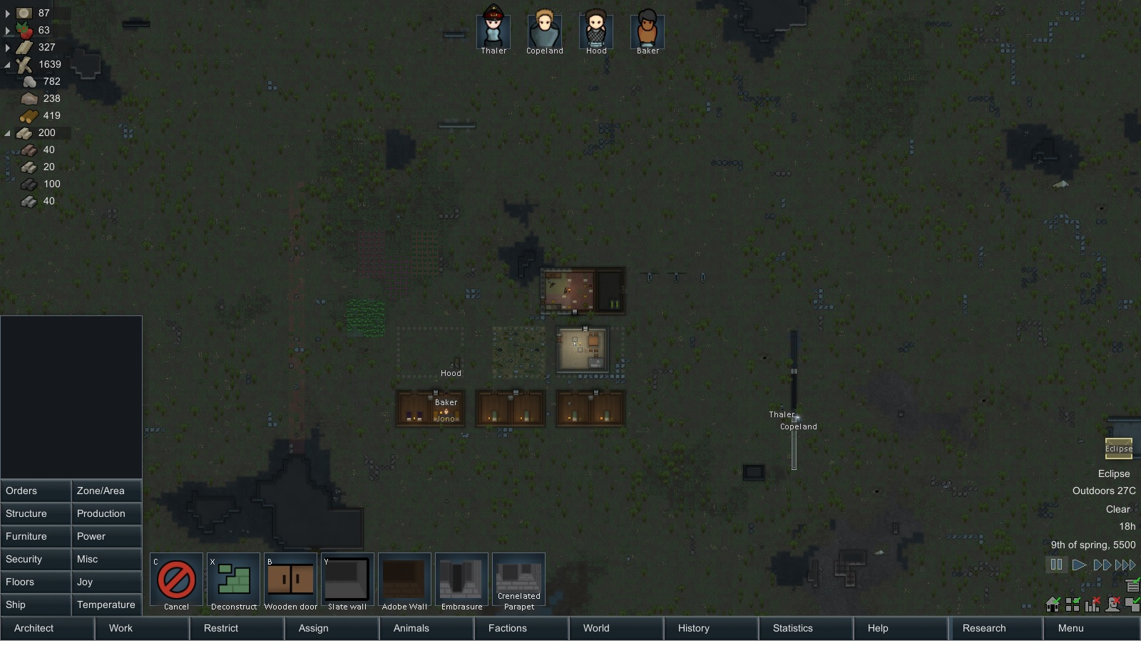
Eclipses: That's why I hate solar panels

Loading....
Extracting readable data....
Seventh Transmission Starts:

Extract from Baker Diary:

''These people are nice but soooo weird. Today everything went black. A Goddamn eclipse. Nothing anormal there but it got the Twitchy abit nuttier than usual, when it started, he went around like a made rabbit and screaming ''They know ! They are commmmming for us ! '' and went hiding in his room while at the same time the big Guy wont stop doing the Macarena (I regret showing him that one). The little mute cutie just seems to have accepted that crazyness and just shakes her head in exasperation at the two others guys constant circus. Man this place is weird. Summer must be coming because its getting abit hot in here''

End of Seventh Transmission
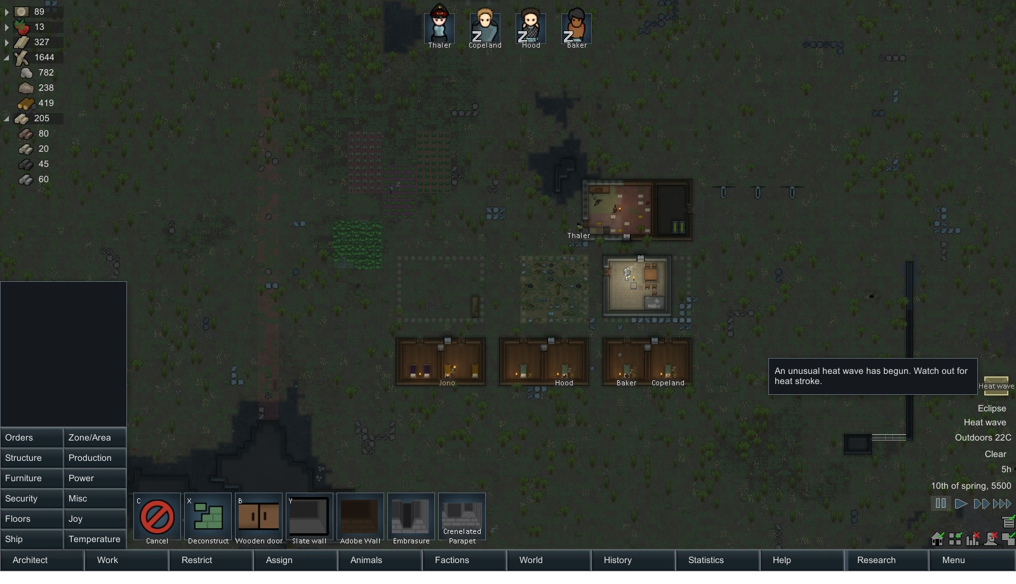
Heat Wave. Thank god for A/C

Day 14: Jono Joint.
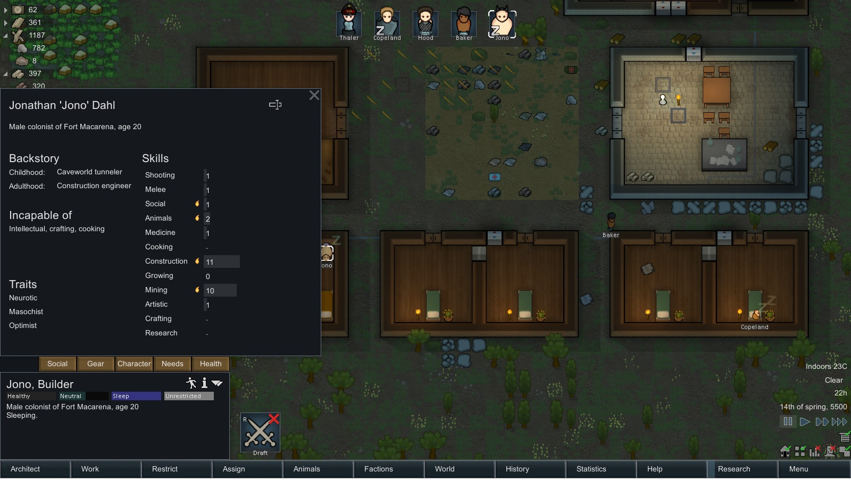
Jono' Stats. Another Neurotic. Thats what we needed. And he is an optimist masochist. CAN I HAVE ONE MORE SIR ? ''Slap'' THANK YOU SIR ! - Animal House.

Loading....
Extracting readable data....
eighth Transmission Starts:

Extract from the diary of Jonathan, Jono, Dahl, Construction Engineer and reformed Pirate.

''Yes I was a murdered before. But oy ! A man has to make a living no ? Ain't no much job offers for construction engineers here you see. But after a few talk with that Baker dude and that other nice fellah, Hood (They call him Twitchy but he seems quite normal to me) * scratches neck* I figured out; well fuck it, yes they stabbed me but they patched me up and haven't tried to sell my organs to anyone so far so fuck it. I'll help them out. They need a big wall to be built, so that fits right in with my sets of skills. As for the joy of killing and pillaging, well, I recon that with the kind of neighbours this place has, there will be plenty of that coming to us here.''

End of eighth transmission.

Day 15 Medieval Visitors and End day !
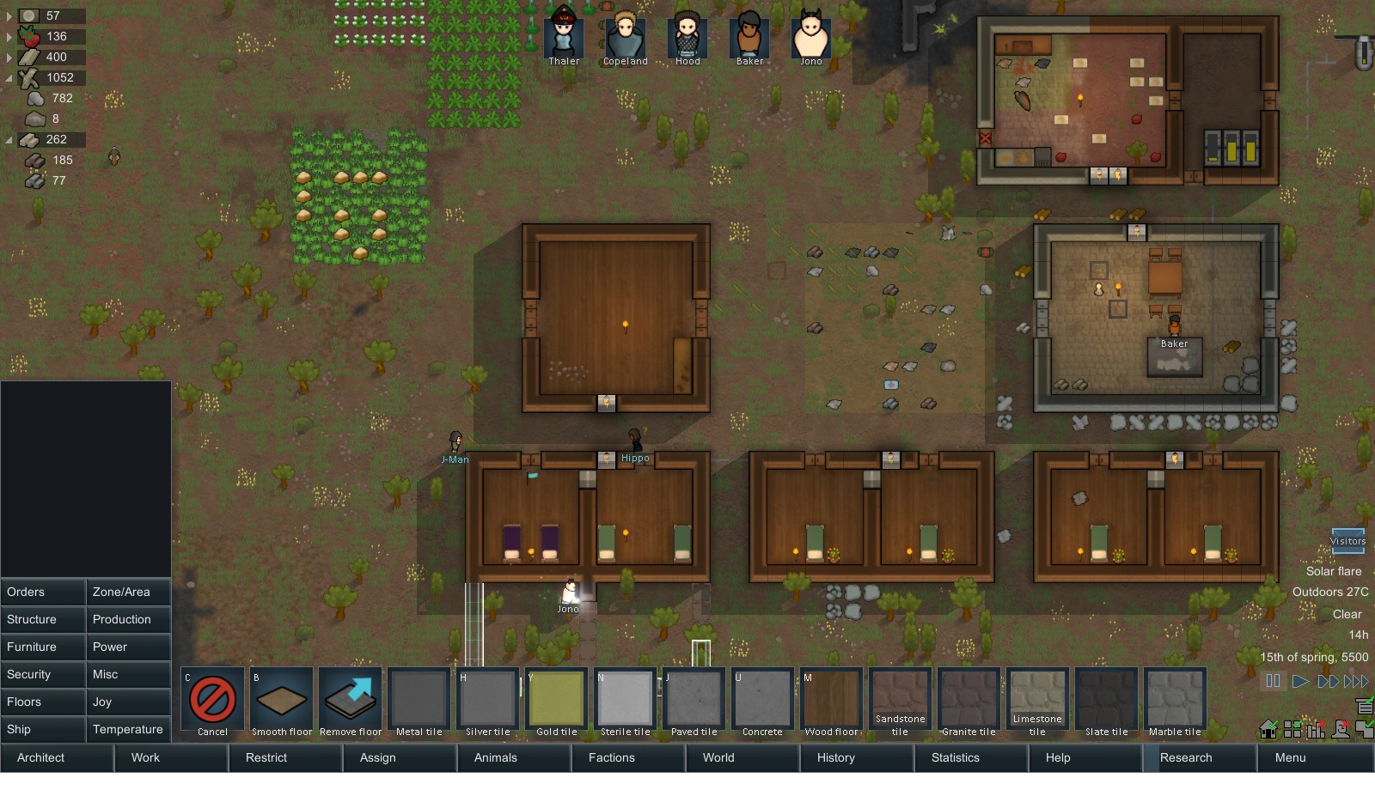
Medieval Visitors

Loading....
Extracting readable data....
ninth Transmission Starts:

Extract from Thaler's diary:
''More visitors today, they were dressed weird as fuck like those old ''Robinhood'' movies of old earth. But overall they were fine lads and I think....

Extract form Howard Diary ''MACARENA! Howard!. Macarena !''

Extract from Thaler's diary: ''FML.''

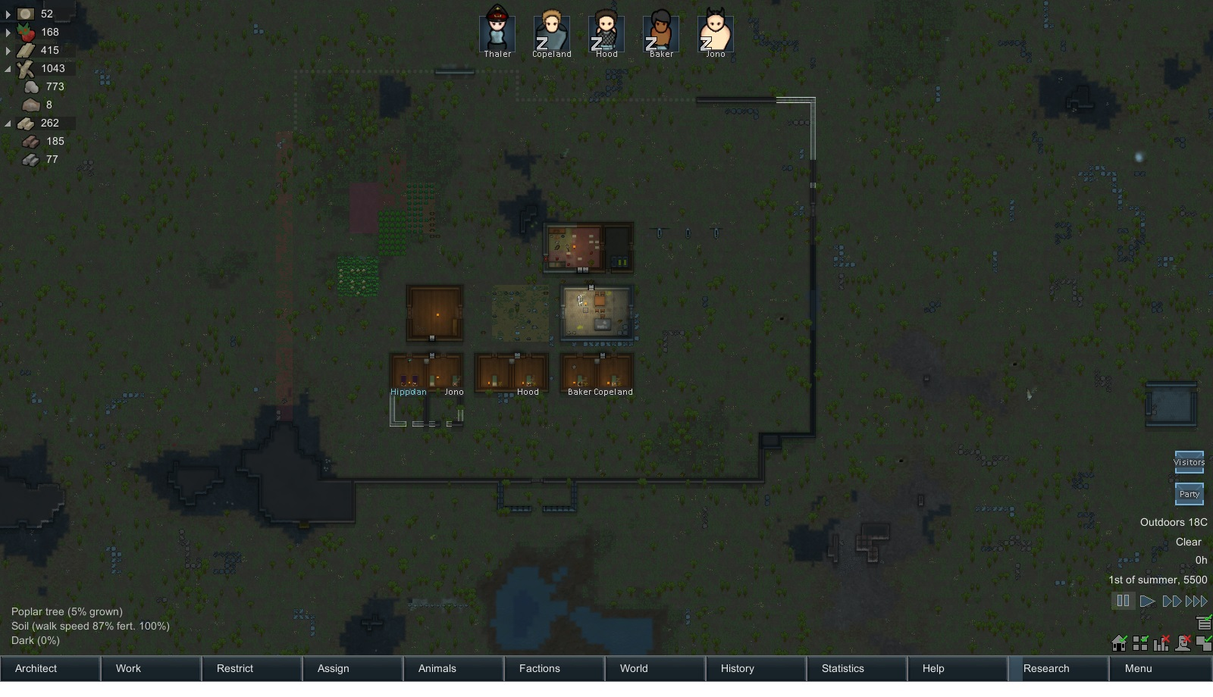
Last day of Spring with Howards party !

